The Palestinian Nakba:
a presentation and book signing event about the Palestinian situation

featuring

Nahida Halaby Gordon, PhD

Tuesday, May 15th 5:30- 7:00pm

at
White Memorial Presbyterian Church
Calvin building, McDonald Lane behind 1704 Oberlin Road

Light refreshments

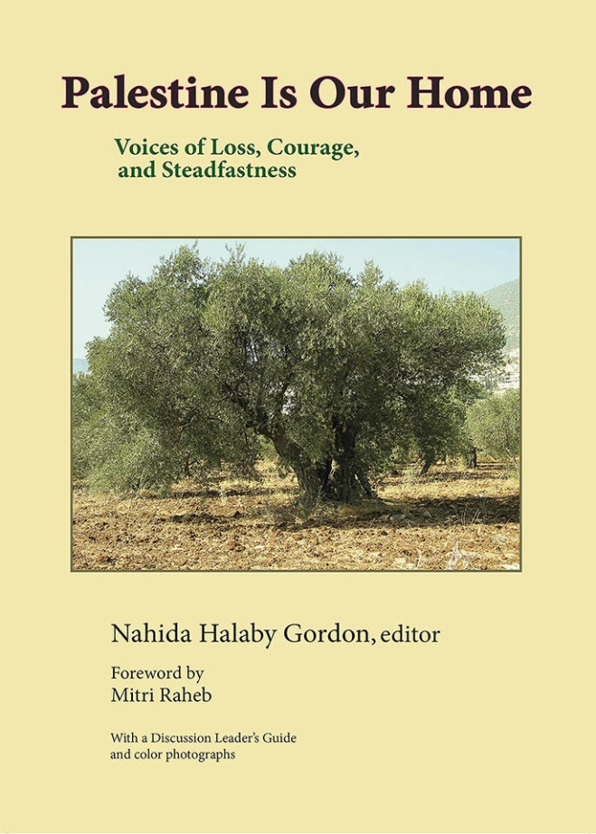
Nahida Halaby was 9 years old, in April, 1948, living in Yafa (Jaffa), the famous, ancient port city of Palestine when her family quickly packed what they could and hastily drove to Lebanon to escape the escalating bombing following Britain’s stated intention to leave after the 1947 UN partition of Mandate Palestine.
Once the danger ended, they intended to return to their home and her father’s successful import business – but were never permitted to do so.
Read more at:
Justice Unbound
an Interactive Journal of Christian Social Justice
justiceunbound.org/carousel/this-is-my-story/
“Within [this book], one can experience first-hand the pathos, resilience, and aspirations of the Palestinian collective through the narratives of individual Palestinians who have undergone dispossession, denial, and exile.” (Hanan Ashrawi)

Sponsored by The Coalition for Peace with Justice
www.cpwj.org
with appreciation to Middle East Peace with Justice Committee of White Memorial Presbyterian church for hosting this event

